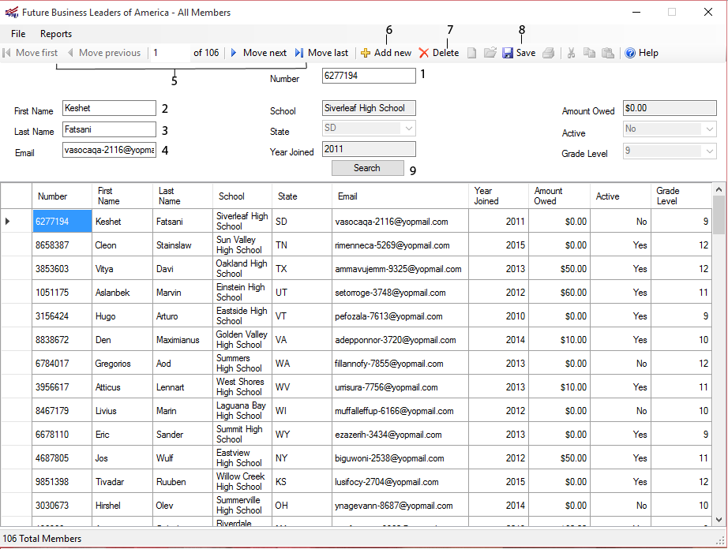

1. Displays the member number of the current student
   1. Searchable
2. Displays the first name of the current member
   1. Searchable
3. Displays the last name of the current member
   1. Searchable
4. Displays the email address of the current member
   1. Searchable
5. Buttons to navigate the database
6. Button to add a new member to the database
7. Button to delete the selected student from the database
8. Button to save the changes made and update the database